A User’s Guide to MazeWalker

By Stephen Fulton, Shawn Parkes, Rebekah Manweiler

The following link will take you to a game called MazeWalker. <https://people.eecs.ku.edu/~sfulton/MazeWalker/>. This game does not work in Internet Explorer and has not been tested in Safari, but has been used successfully in Mozilla Firefox, Microsoft Edge, and some versions of Google Chrome. A note for Chrome users: if the game is not working properly, type *chrome://flags/* into your address bar. Look for the *Disable WebGL* flag and instead enable it. This game can be rendered on a mobile device and the camera can be moved with a touch screen, but the player cannot move without the WASD keys.

Once the page has successfully loaded, you will see the following screen. 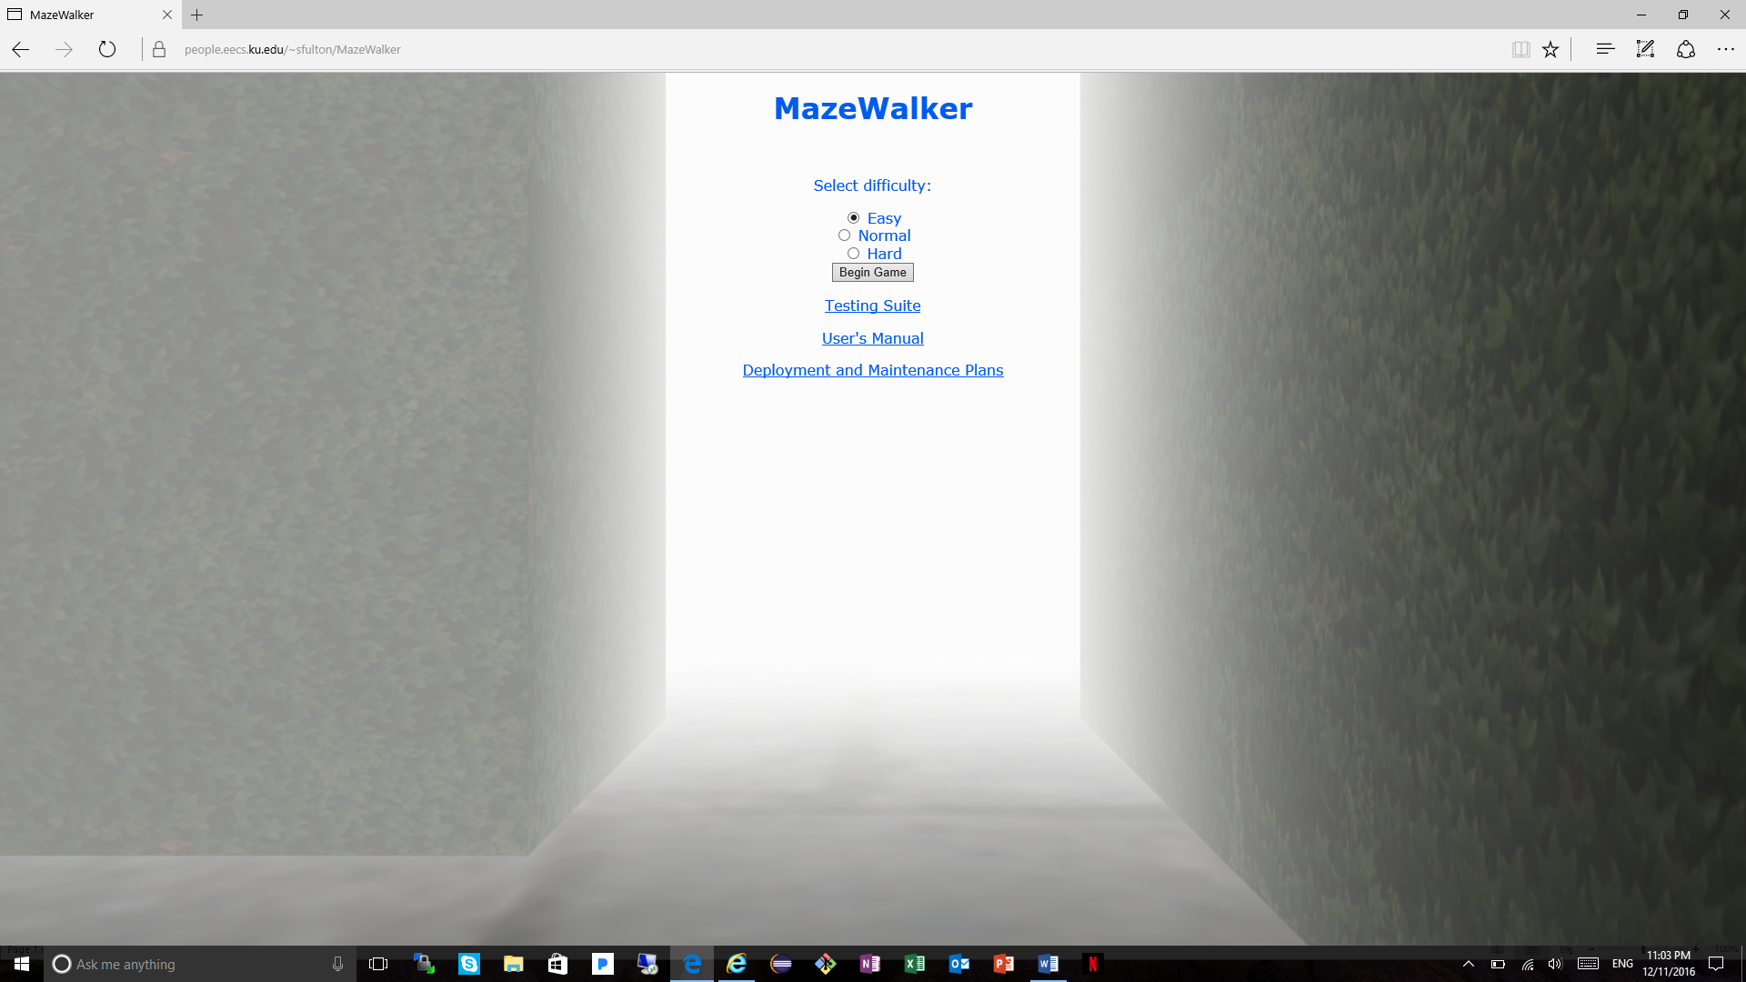

At this screen, you can choose your difficulty with the radio buttons labeled “Easy”, “Normal”, and “Hard” and then begin the game by pressing the button labeled “Begin Game”. You can also choose to click on links below the button to access the Testing Suite, the User’s Manual (this document), and the Development and Maintenance Plans. If you chose to click on the link to the Testing Suite, you will see the following screens. 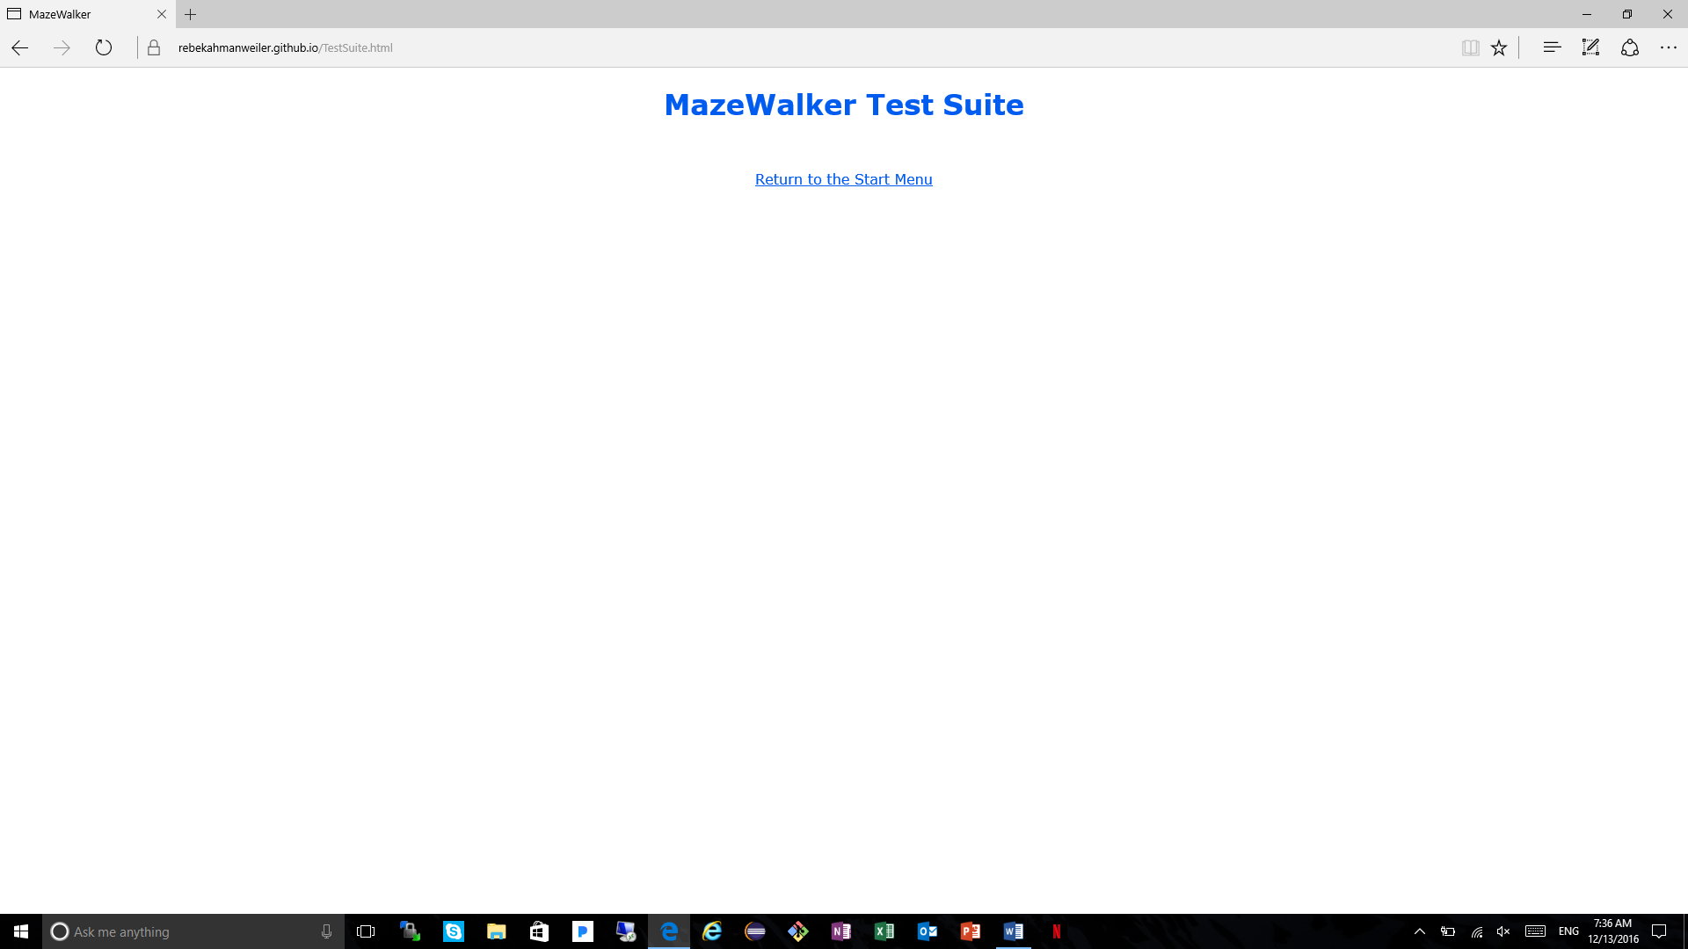

This screen will appear for a brief moment while the testing suite is executing, and then you will see the test output on the following screen.

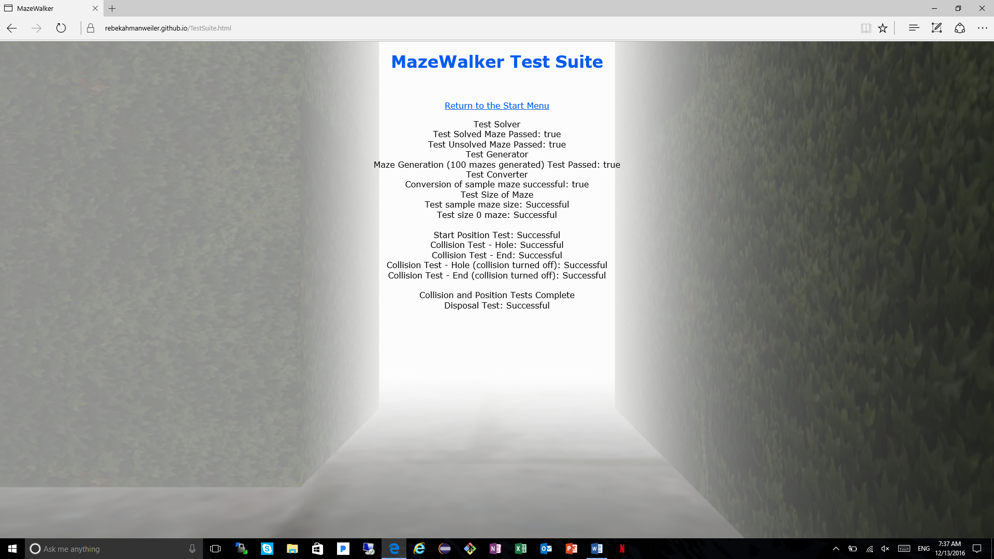

This screen shows a short summary of the tests that were completed in the testing suite and if they were successful, or if they failed. On the same page, you may click the link above the test output to return to the main page.

Back on the main page, if you chose to click on the link to the User’s Manual, you would view the following screen.

This screen contains a link to the pdf form of this document as well as a link back to the main page.

Back on the main page, if you chose to click on the link to the Deployment and Maintenance Plans, you would see the following screen.

(blurb about screen).

Back on the main page, if you chose to keep the selected difficulty (Easy) or changed the difficulty setting and clicked the “Begin Game” button, you will see the following screen.

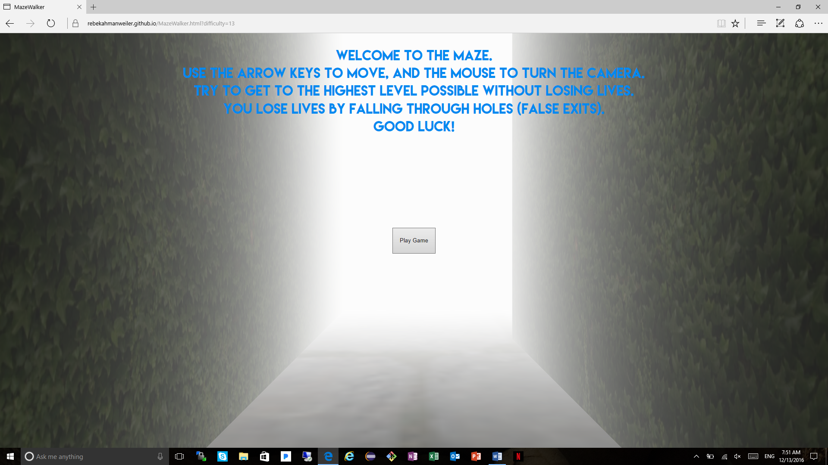

You will see a short paragraph explaining the controls and the goals of the game. At this screen, you will not be able to move or turn the camera until the “Play Game” button is clicked and the opening paragraph is hidden. Once the button is clicked you will see something like the following screen. 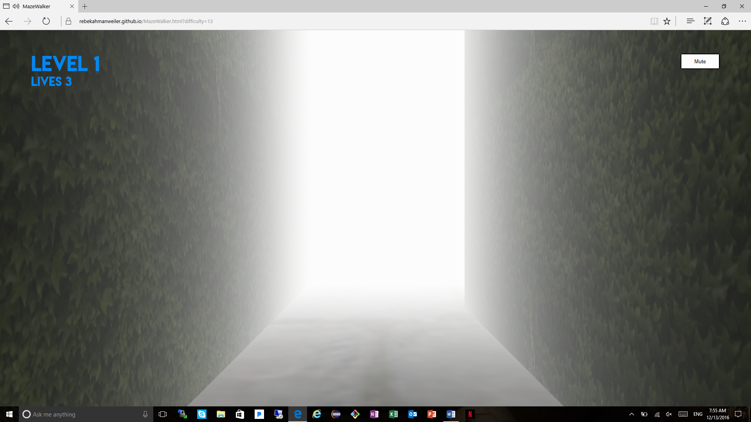

You may not see this screen exactly, because each new maze that you encounter is generated randomly and you may have a different path following the starting position.

As you move around the game, you will always be able to see three things in the top corners of your screen. In the upper left-hand corner in the larger text you will see the current level you are on. You will always begin at Level 1 and continue to higher levels. In the same upper left-hand corner in the smaller text you will see your number of lives. You will always begin with three lives and the game will end when you no longer have any lives. In the upper right-hand corner of the screen you will see a “Mute” button. This button will mute the background music that plays as you travel through the mazes. This button does not mute the extra sound effects of the game. When the button is clicked and the music is being muted, the button will turn blue. At this point you may click the button again and the music will begin playing and the button will return to its original color.

To move through the mazes, you will use the WASD keys to move yourself forwards, left, backwards, and right respectively. These keys move the player but do not change the direction you are looking. To change the direction, left click the mouse or mousepad and drag the mouse in the desired direction. On some computers, you may double left click on the mouse and drag freely without having to re-click the mouse, but this does not work on all machines. The easiest way to control the looking direction of your player is to use a physical mouse instead of the mouse pad. **Warning: to begin moving you must first click and move the mouse** (just go with it).

Now that you are able to move through the maze, your goal is to find the exit of the maze. The following screen shows an exit that was found on the first level of a maze.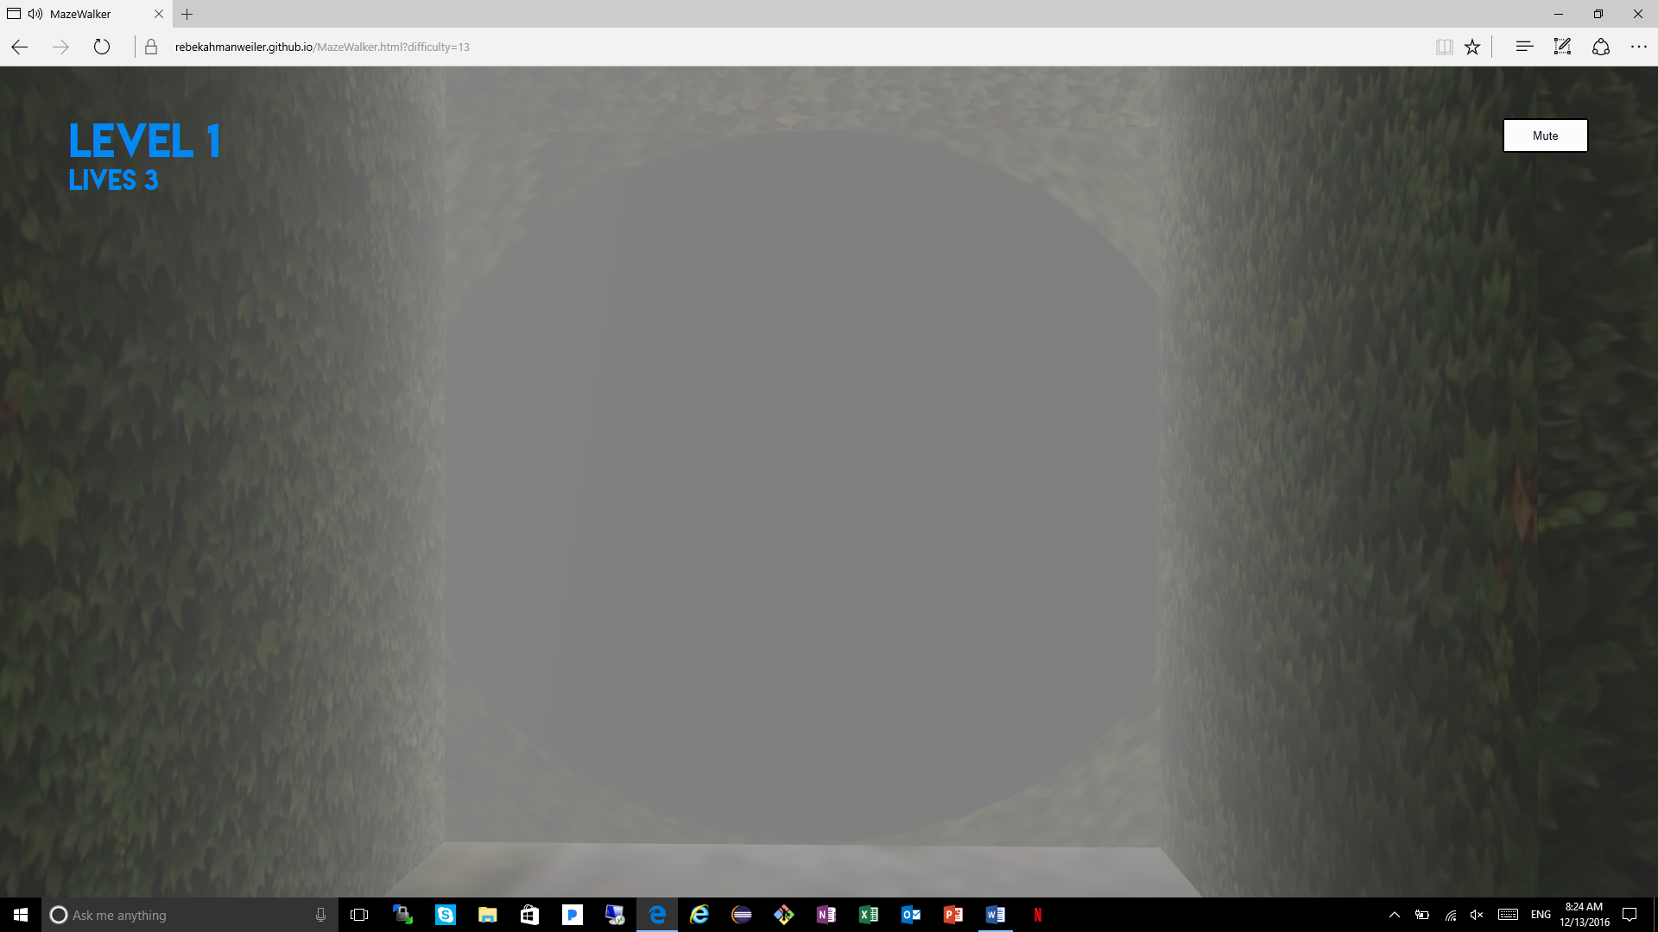

There will be exactly one exit like this one on every level of the game for you to find. The next screen shows a hole that was found on level two.

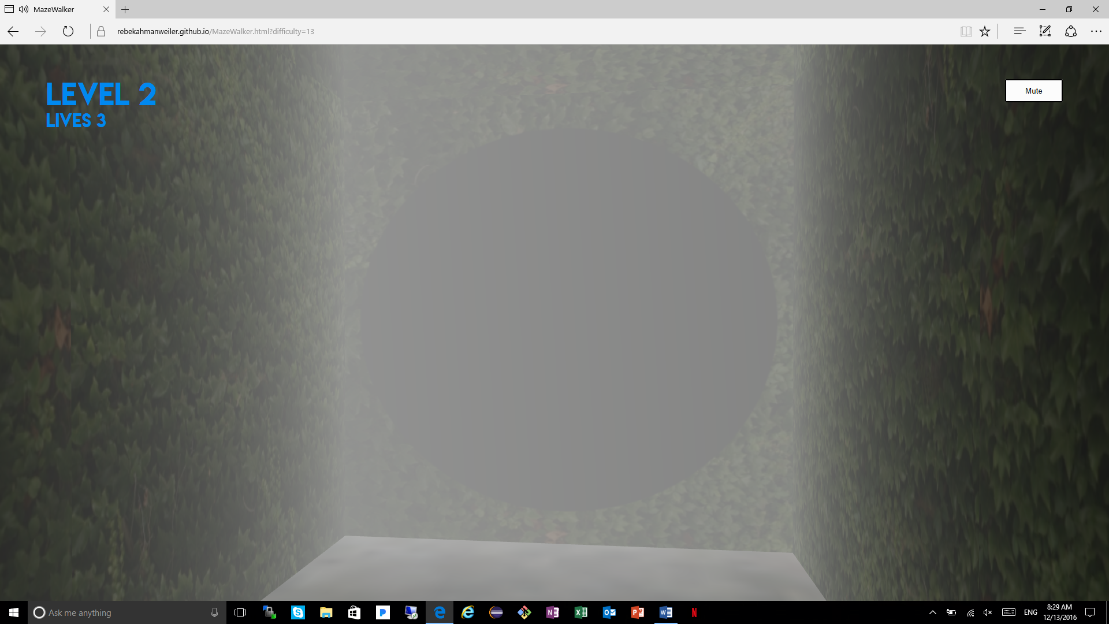

You may accidentally fall down these holes to the previous level and lose a life if you get too close! These holes can be found on every level except for level 1. If you collided with the hole above, you would see the following screen. 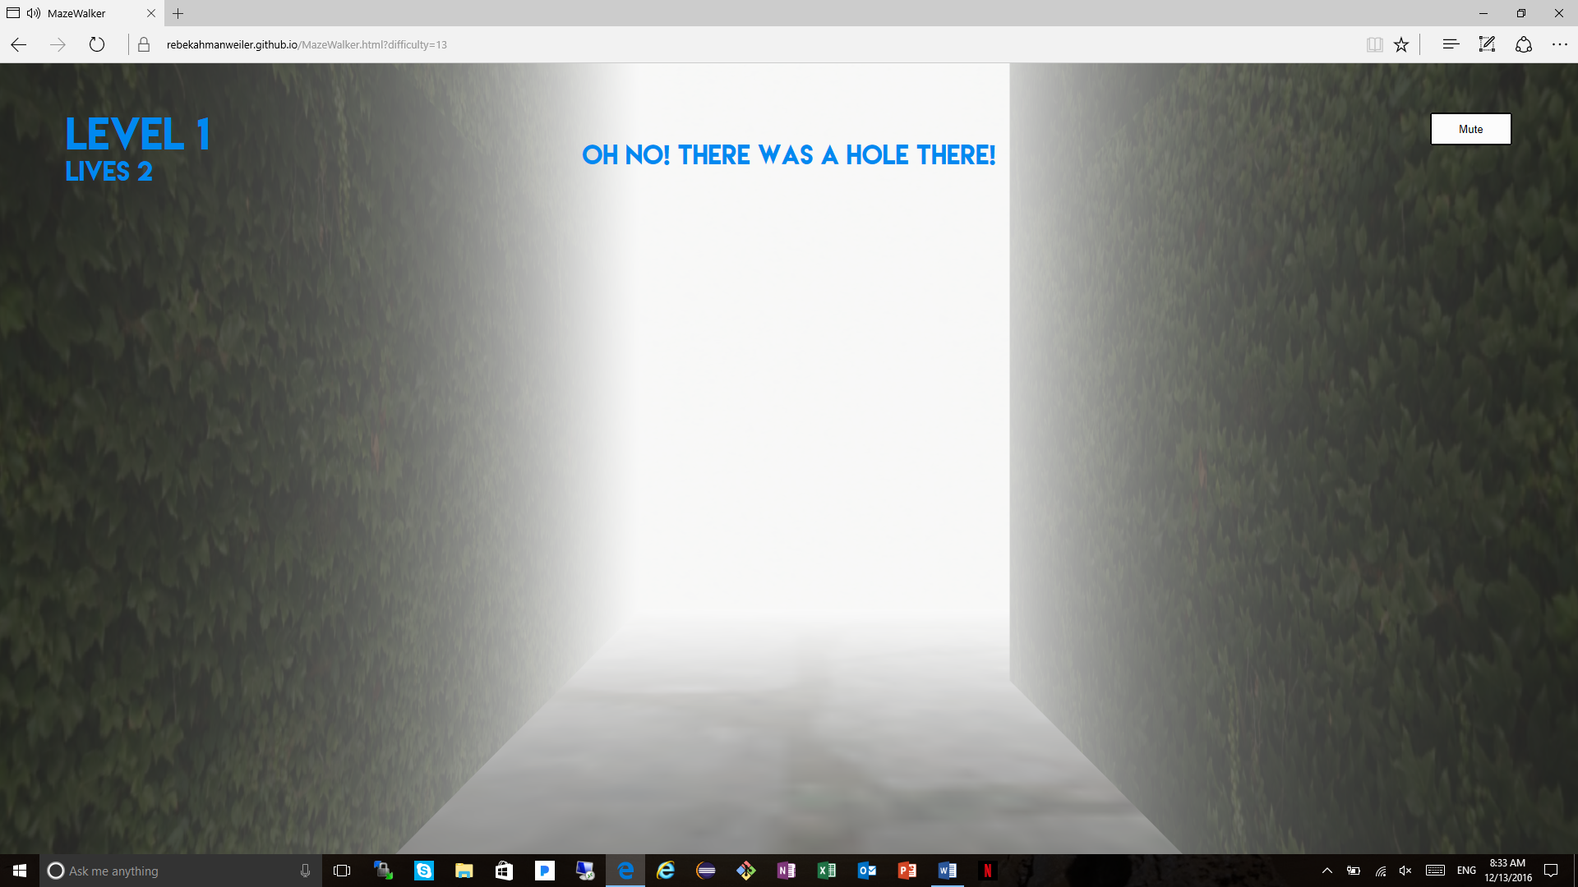

You will be dropped back into the starting position of the previous maze and your lives will be decremented by one. You will also see the message “Oh no! There was a hole there!” for a short period of time. You may resume movement instantaneously after you fall through the hole to look for the same exit that you found previously for this maze.

The goal of the game now is to get to as many mazes as you can before you lose all of your lives. When you fall through your third hole, you will see the following alert.

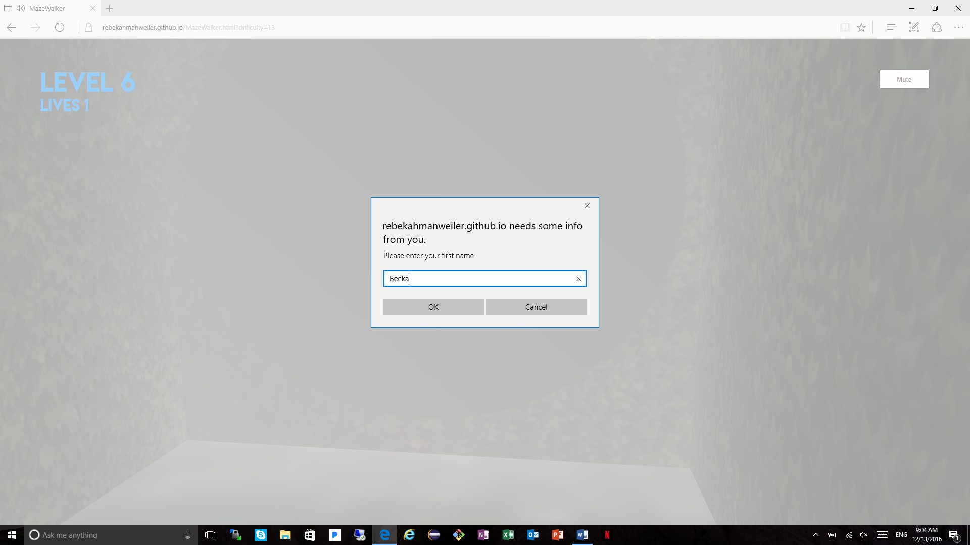

Here you can enter your name to appear with the highest level you got to on following page. 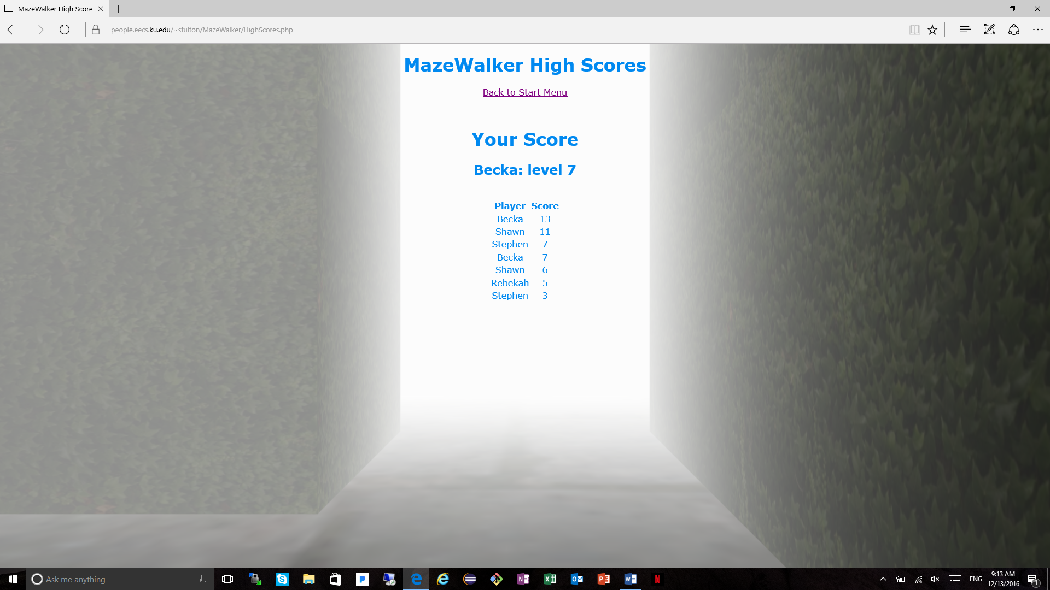

Now, your game has been completed and you can follow the link back to the main page to begin again!